1. Soil C pool data was from Bulk density and organic calculation.

The paper does not report carbon density directly. We calculated carbon density from Table 4, which reported percent organic matter and bulk density, but not carbon concentration. To calculate carbon density, their data were entered into a spreadsheet, then processed with SAS code to calculate carbon density. The calculation steps were as follows:

a. Convert organic matter (OM) to organic carbon units.

We used the following equation developed by James Holmquist (in review):

SoilCC=0.074*(OM/100)*(OM/100) + 0.421*(OM/100) - 0.0080, where

SoilCC = C concentration in units of grams C per grams soil

OM = organic matter concentration in units of grams OM per grams soil

b. Convert soil carbon concentration (SoilCC) to carbon density.

SC=SoilCC*BD, where

SC=Soil carbon density in units of grams carbon per cubic centimeter (g/cm3)

c. Soil carbon accretion rate (SCrate) was calculated from the soil C and accretion rates from table 2.

SC_rate= SC * Accretion_rate*10000 (SC_rate unit is g C m2 yr-1).

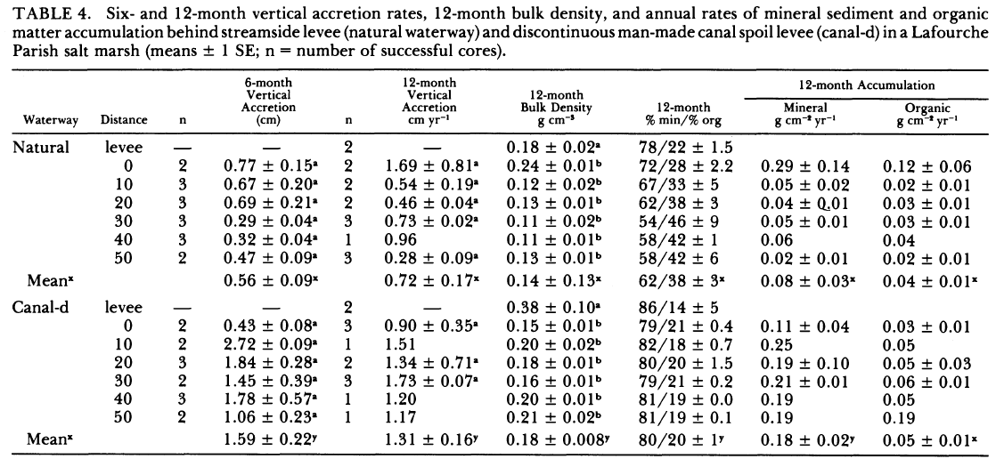

Meng was not able to repeat the calculation to get the same number on the master datasheet.

***[Response from Blanca]*** *Ignore rows 187-189, it is the same paper. For row 121-126 use data on table 1 and table 5. Again, the numbers of gC/cc are almost the same, but you can update them with the same calculation as above. Make sure you use 12- month %org.*

Done as suggested

Table 1.

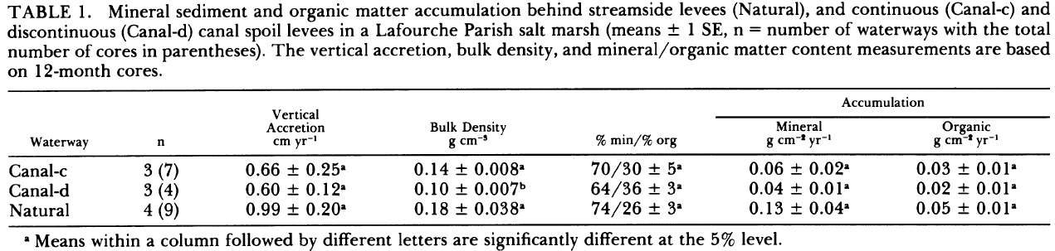

Table 5.

